HOW TO SETUP PRISMA LOCALLY USING DOCKER?

STEPS:

1. Create a new folder (finalPrisma)
2. Open a command prompt inside that folder
   1. Run: prisma init 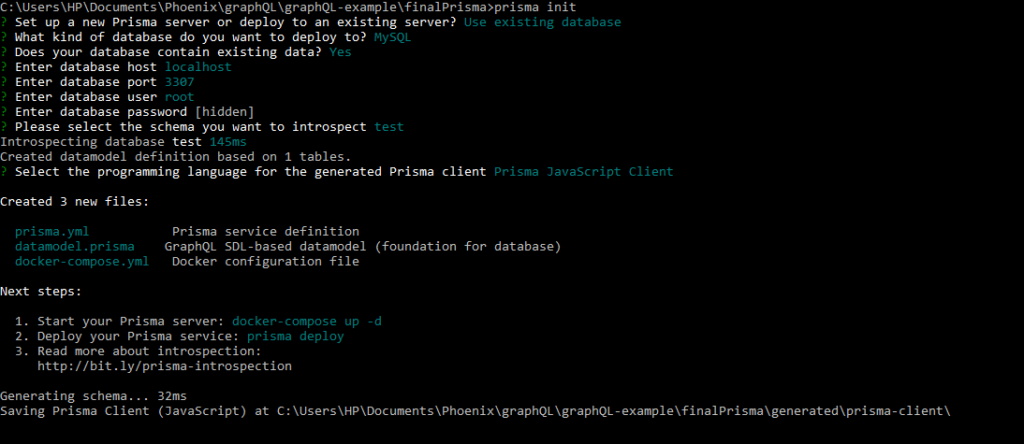
   2. The folder structure inside the folder appears like this
   3. 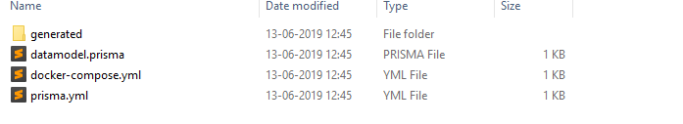
3. Create an .env file using sublime text and fill in the following text inside it
   1. SQL_PASSWORD=password
4. Copy and paste the following code inside the docker-compose.yml (I have used port 3307:3306 because mysql is listening to port 3307)

version: '3'

services:

prisma:

image: prismagraphql/prisma:1.34

restart: always

ports:

- '4466:4466'

environment:

PRISMA_CONFIG: |

port: 4466

databases:

default:

connector: mysql

host: mysql

port: 3306

user: root

password: password

migrations: true

mysql:

image: mysql:5.7

restart: always

environment:

MYSQL_ROOT_PASSWORD: $SQL_PASSWORD

ports:

- '3307:3306'

volumes:

- mysql:/var/lib/mysql

volumes:

mysql: ~

1. Run: docker-compose up -d
2. Run: docker-machine ip
   1. 192.169.99.100 will appear as output
3. Change the endpoint: in prisma.yml to <http://192.168.99.100:4466>
4. Run: prisma deploy
   1. You will get output something like this! (I am so happy that I got this finally!)
   2. 